39 Gordon Street, Huntly, Aberdeenshire AB54 8EQ

Telephone: 01466 792627 Fax: 01466 794962

VETERINARY SURGEONS
STRATHBOGIE VETERINARY CENTRE LTD

Read on there are jokes at the end of the newsletter!
Colostrum, some facts and figures for you. Like with all things….. you get what you pay for. Think about it another way….. your Glens never tastes as good as your Grey Goose vodka and your Famous Grouse compared to a Glenfiddich.
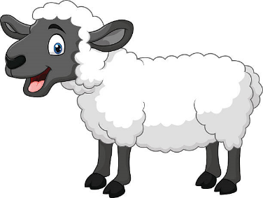Colostrum is required to give the newborn the best start to life as possible. The amount of immunoglobulins (antibodies) absorbed by the gut of the newborn declines rapidly to zero over the first 24 hours of life. Failure of passive transfer of immunity is a significant problem in both lambs and calves and can contribute to many other causes of neonatal deaths. Its not all about the antibodies either….. colostrum provides fat which is broken down to generate heat for the neonate – again important to ensure the animal does not suffer from hypothermia – a common finding in sick, ‘flat’ calves. Following birth animals lose heat very quickly and have a limited ‘brown fat’ supply in their body. As you are all aware there are many different brands of colostrum available, differing in quality, quantity and also price! There have been several studies done to compare; immunoglobulin (IgG) concentrations and fat content (the most important being immunoglobulins!) There was found to be a significant difference between brands, ‘immunocol platinum’ being the highest of the colostrum supplements. (Please look at the graph below)
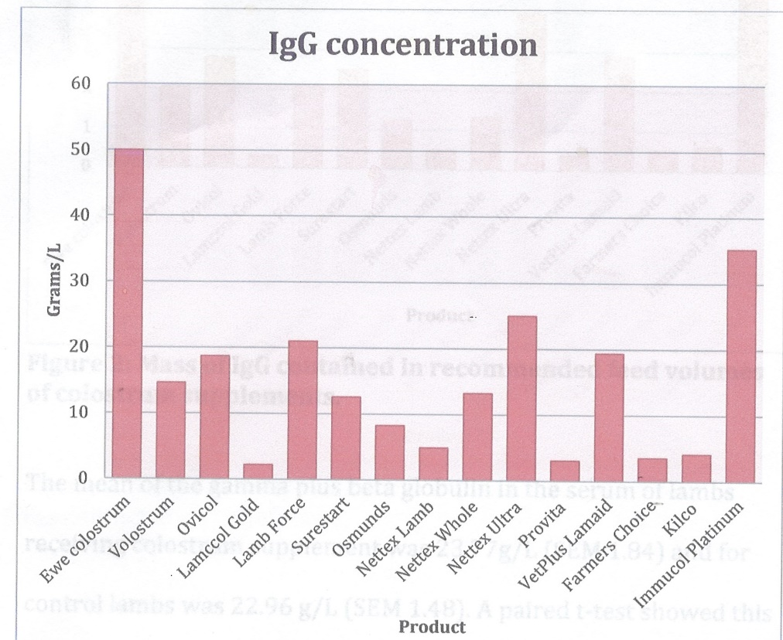

However, this is all well and good but please note that none of these supplements provide the same level of antibodies as mother natures ewe / cow colostrum. If possible give calves colostrum from the mother (or another animal on the farm), but supplements should be given to ensure the neonate receives adequate colostrum. I hear you ask… How much do lambs or calves require? A rough guide is 10% of bodyweight in calves in litres (4 litres being in the first 4-6 hours), and in lambs 50ml/kg in the first few hours of life. If in doubt tube!
Please make sure that the colostrum you purchase is certified as Johnes, IBR and EBL free – as these can be passed via milk to the calf. A spare bag of colostrum never goes a miss, feel free to ask about the ones we stock.
A bit of housekeeping…. Abortions…. All cattle abortions should be reported to us! We then inform the ministry and need to come out and take samples from the cow (and calf if needed) to test for Brucellosis. There is no charge for this visit. Additional samples can be taken and sent to the lab for analyse samples for other infectious causes (there will be a lab fee for this!)

LAMBING LIST
• Spectam Scour Halt
• Orojet Lamb
• Colour spray markers
• Lubrel
• Oxytetracycline antibiotic spray
• Lambing ropes
• Nylon Tape
• Thermometers
• Syringes and Needles
• Ovivac P plus
• Heptavac P
• Rubber rings
• Ring Applicator
• Teats
• Lamb colostrum
• Milk Replacer
• Lamb feeder kit
• Iodine 400ml
• Calciject 400ml
• Glucose inj
• Cetophyton
• Provita Energy
• Penicillin
• Lamb Jackets
• Rehydion Gel
• Sensiblex

